NEON AOP HDF5 ENVI Extension Install Guide

© 2015 NEON Inc.

Written By: Josh Elliott [jelliott@neoninc.org](mailto:jelliott@neoninc.org)

For license information, please refer to LICENSE.txt which should have been provided with this distribution.

**Introduction**

This document contains installation steps for the NEON AOP HDF5 ENVI Extension which is designed to allow the user to read data collected by the Airborne Observation Platform (AOP) at the National Ecological Observatory Network (NEON).

This file contains the compiled ENVI extension (.sav file) as well as the source code (.pro files). The source code is released under a BSD style license, for more information refer to LICENSE.txt.

**Requirements**

This plugin requires at least ENVI 5.2.

**Installation**

Locate the following three files, provided with this distribution:

* aoph5toenvi.sav
* NEON-Logo.png
* smallneonlogo.png

Place these three files into the following location (depending on your platform):

Windows: C:\Program Files\Exelis\ENVI52\extensions\

Mac: /Applications/exelis/envi52/extensions/

Linux: /usr/local/exelis/envi52/extensions/

ENVI installation locations may vary, check with your system administrator if you cannot find these directories. If you do not have permissions to write to this location, you may also place these in your user ENVI/IDL configuration directory, typically located here:

Windows: C:\Users\<user name>\.idl\envi\extensions5_2

Mac: /Users/<user name>/.idl/envi/extensions5_2

Linux: /home/<user name>/.idl/envi/extensions5_2

**Opening a NEON AOP HDF5 file**

1. To open a file, double click the NEON AOP H5 Reader extension icon, located in the ENVI Toolbox extensions folder:

C:\Users\jelliott\Desktop\neonextension.PNG

1. Select a file, or multiple files, to work with and click “Open”:

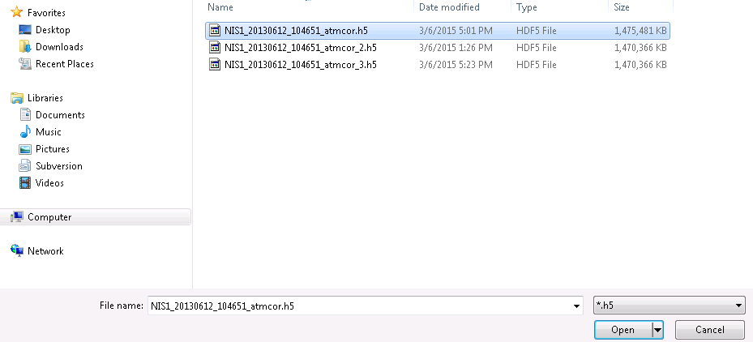

1. Select the dataset, or multiple datasets, you wish to open, and click “OK”:

